9Recitation 6

Introduction to the FPGA Board

# Introduction

In this recitation, you will learn how to load your design on reconfigurable hardware (i.e., the FPGA chip on our DE2 board) and run it on it. FPGAs are integrated circuits that mainly use look-up tables (LUTs) to reconfigure themselves electronically.

# Collaboration Policy

You will be working in groups of 2-3. Groups are allowed to collaborate.

# Equipment

* Computer with Quartus Prime software
* DE2 FPGA board
* DE2 board manual found under Sakai → Resources
* FPGA Blast Tutorial found under Sakai → Resources

# Tasks

To receive credit for this lab, you must complete:

* Task 1: Light up LEDs on the FPGA board
* Task 2: Create a 3-bits adder and show results on 7-segment displays

You must complete all parts to receive credit. Ensure that a TA marks the completion of the tasks in Sakai.

# Grading

* Completing Recitation Tasks: 1 point (pass/fail)

Control the LEDs on the Board

Create a new project and use the following Verilog code:

module led_test(led_high,led_low,clk,rst_n,s0);

output[1:0] led_high;

output[1:0] led_low;

input clk,rst_n,s0;

reg[1:0] led_high,led_low;

always @(posedge clk or negedge rst_n) begin

if(~rst_n)

led_high <= 2'b00;

else

led_high <= led_high+1'b1;

end

always @(*) begin

case(s0)

1'b0 : led_low <=2'b01;

1'b1 : led_low <=2'b10;

default:led_low <=2'b00;

endcase

end

endmodule

After copying the code, make sure you click “start compilation” to accomplish a full compilation.

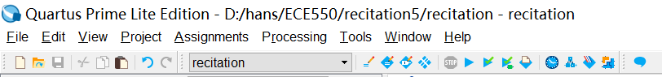

Make sure the full compilation is successful.

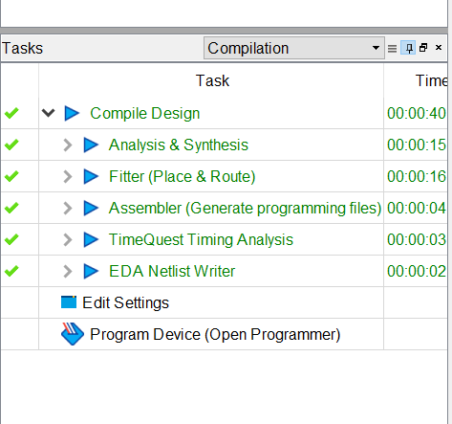

**Pin assignment:**

Find and click on the “Pin Planner”.

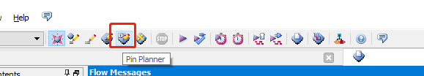

Assign your inputs and outputs to appropriate FPGA pins.

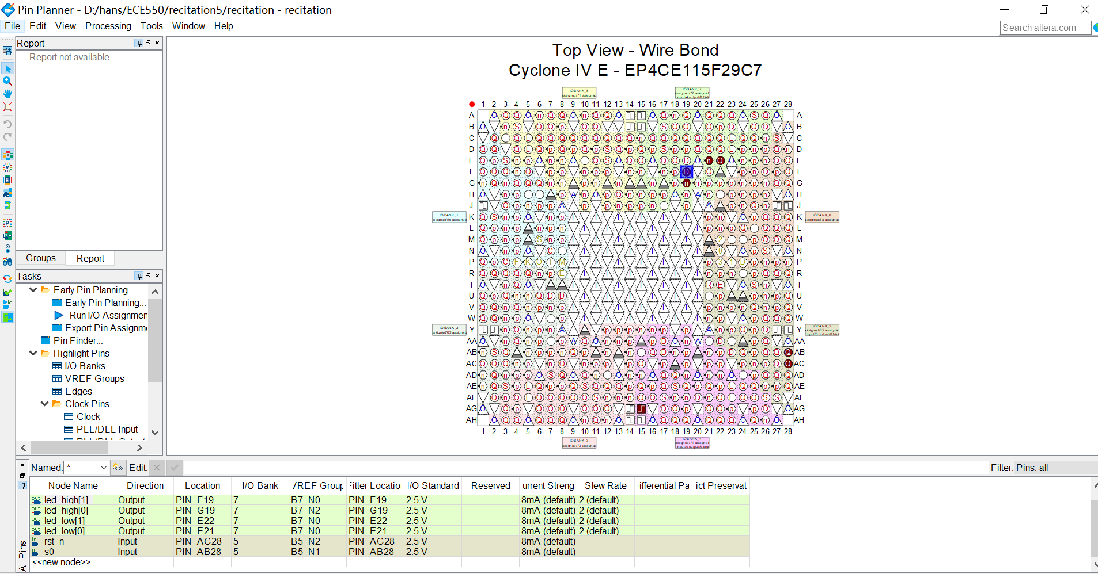

You can connect the locations with node names as seen in the following figure.

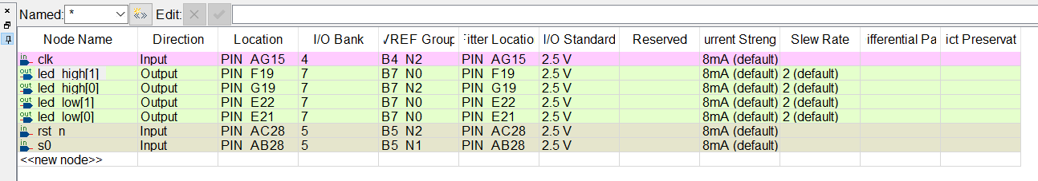

The chosen LEDs are LEDR0, LEDR1, LEDG0, and LEDG1. You can change the location of some LED lights and observe different outcomes.

Close the “Pin Planner” window.

Click “start compilation” again.

Select “Programmer” under “Tools”.

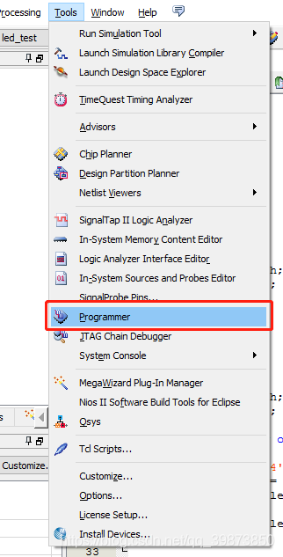

Za

Click “Hardware setup”.

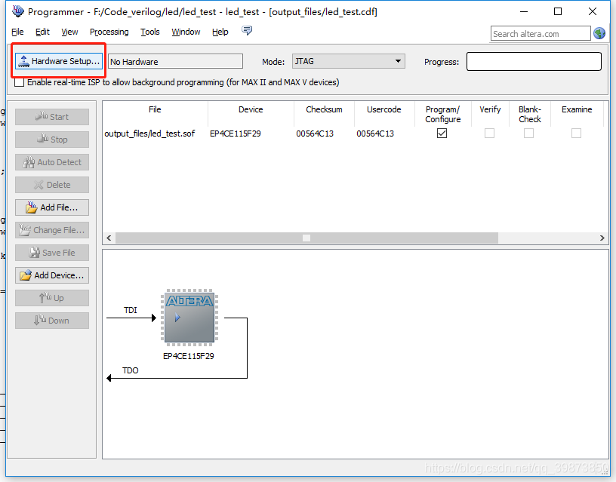

If it shows “No Hardware”, try to move the USB ports. If it still doesn’t work, it is because it is the first time you connect the FPGA to your computer. In that case, you will need to install the USB Blaster Driver by following the instructions found here:

<https://www.terasic.com.tw/wiki/Altera_USB_Blaster_Driver_Installation_Instructions>

This is what you should be able to see:

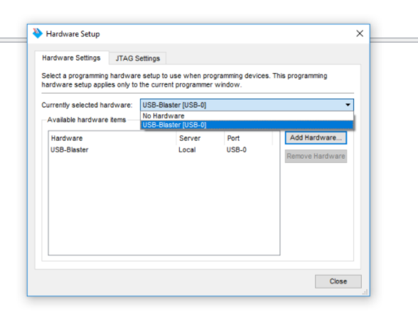

Click on “Select Files” and navigate to “output_files”. Select the .sof file corresponding to your compiled module. Click “Start”.

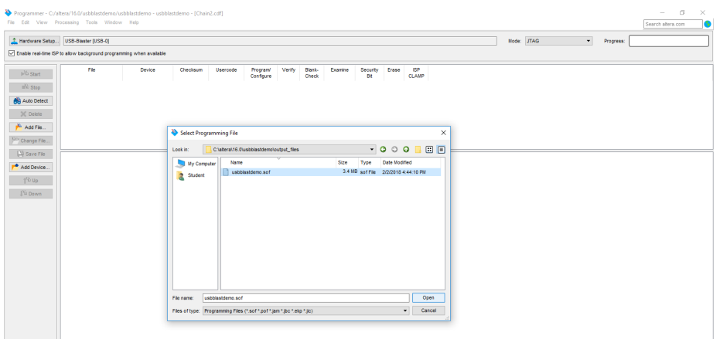

Test your work and show it to a TA.

You can find the information related to LEDs on page 35 of the DE2 board manual.

It can be found under Sakai → Resources.

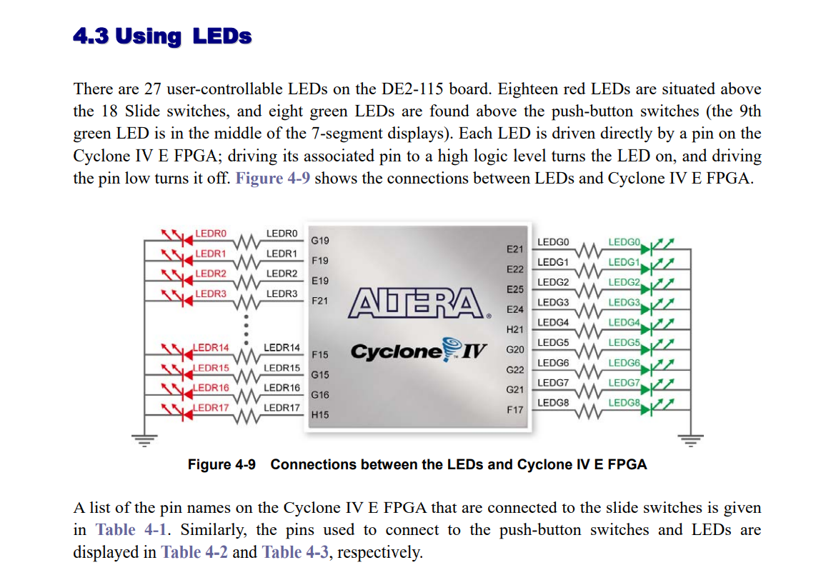

Build a 3-bit Adder and Control It on the Board

Add the code below to a new file. The following code contains two modules. One is a 2-bit adder and the other helps you display one number on a 7-segment display.

module twobitadder(

input [1:0]a,b,

input cin,

output [0:6] HEX1,HEX0

);

reg [3:0]sum,cout;

always@(*) begin

cout <= 0;

sum <= a + b + cin;

end

sevensegment sevensegment0(sum,HEX0);

sevensegment sevensegment1(cout,HEX1);

endmodule

module sevensegment(

input [3:0]in2,

output reg[6:0]display

);

always@(*) begin

case(in2)

0 : display = 7'b0000001;

1 : display = 7'b1001111;

2 : display = 7'b0010010;

3 : display = 7'b0000110;

4 : display = 7'b1001100;

5 : display = 7'b0100100;

6 : display = 7'b0100000;

7 : display = 7'b0001111;

8 : display = 7'b0000000;

9 : display = 7'b0000100;

default: display = 7'b1111111;

endcase

end

endmodule

Make sure you accomplish the full compilation without error. Follow the instruction of controlling the LEDs to accomplish pin assignment and hardware setup.

The following figure shows our pin assignments.

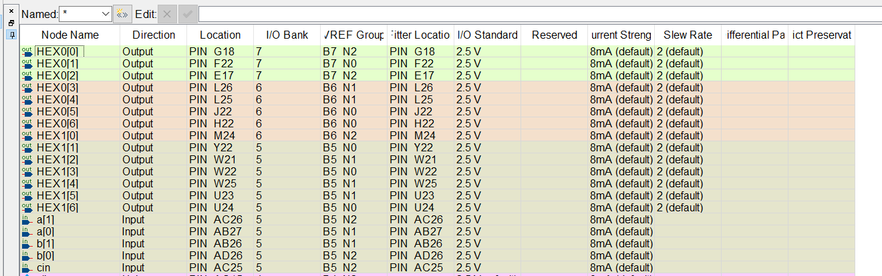

After you finish the whole process, you should be able to alter the inputs by toggling the corresponding sliding switches and the corresponding output will be updated on the 7-segments displays.

Now, change the modules to create a 3-bit adder. You need to add more sliding switches to control the input. The outcome should be shown on **2** seven-segment displays. Show the results to a TA.

You can find the information related to seven-segment displays on page 36 of the DE2 board manual. You can also find information related to sliding switches on page 35.

